**1.Introduction:**

1.1 Overview:

"The Cognos Effect: Unleashing Actionable Insights on the Top 100 KDramas of 2023" is a data-driven research project focused on the Korean drama (KDrama) industry in the year 2023. This project employs advanced data analytics, machine learning algorithms, and natural language processing to meticulously analyse and rank the top 100 KDramas of the year. By delving deep into viewer sentiments, trends, and preferences, the project aims to uncover the factors contributing to the success of these dramas, including storytelling, character development and cultural appeal.

1.2 Purpose:

By leveraging data analytics and advanced technology, this project provides actionable insights into the factors that make certain KDramas successful in 2023. Content creators can use these insights to refine their storytelling and character development, leading to more engaging and popular dramas. Industry professionals can make informed decisions about investment and distribution based on the project's findings. Researchers gain a deeper understanding of the evolving KDrama landscape. Ultimately, this project empowers stakeholders to create, market, and enjoy KDramas that resonate with global audiences.

**2.Literature Survey:**

2.1 Existing Problem:

Korean Dramas and Films: Key Factors for Their International Competitiveness

The KDrama industry is constantly evolving and becoming more competitive. With an abundance of KDramas being released every year, it can be challenging for stakeholders to understand the factors that contribute to the success of a KDrama. Existing approaches and methods to solve this problem may involve manual data collection, subjective analysis, and limited insights.

2.2 Proposed solution:

In this project, we propose the use of Cognos, a powerful business intelligence and analytics software, as a solution to overcome the existing problem. By leveraging the capabilities of Cognos, we can automate data collection, perform objective analysis, and generate comprehensive insights on the top 100 KDramas of 2023.

The proposed solution involves:

1. Data collection: Gathering relevant data on the top 100 KDramas of 2023, including information on genre, actors, production companies, ratings, and audience feedback.

2. Data analysis: Utilizing Cognos to perform advanced analytics on the collected data. This includes identifying patterns, trends, and correlations between different variables to uncover insights related to KDrama success.

3. Insights generation: Presenting the findings and insights in a clear and actionable manner, enabling stakeholders to make informed decisions regarding KDrama productions, marketing strategies, and audience targeting.

By implementing this proposed solution, we can enhance the understanding of the KDrama industry by providing stakeholders with data-driven insights that can guide their decision-making processes and contribute to the overall growth and success of the industry.

**3.Theoretical analysis:**

3.1 Block Diagram

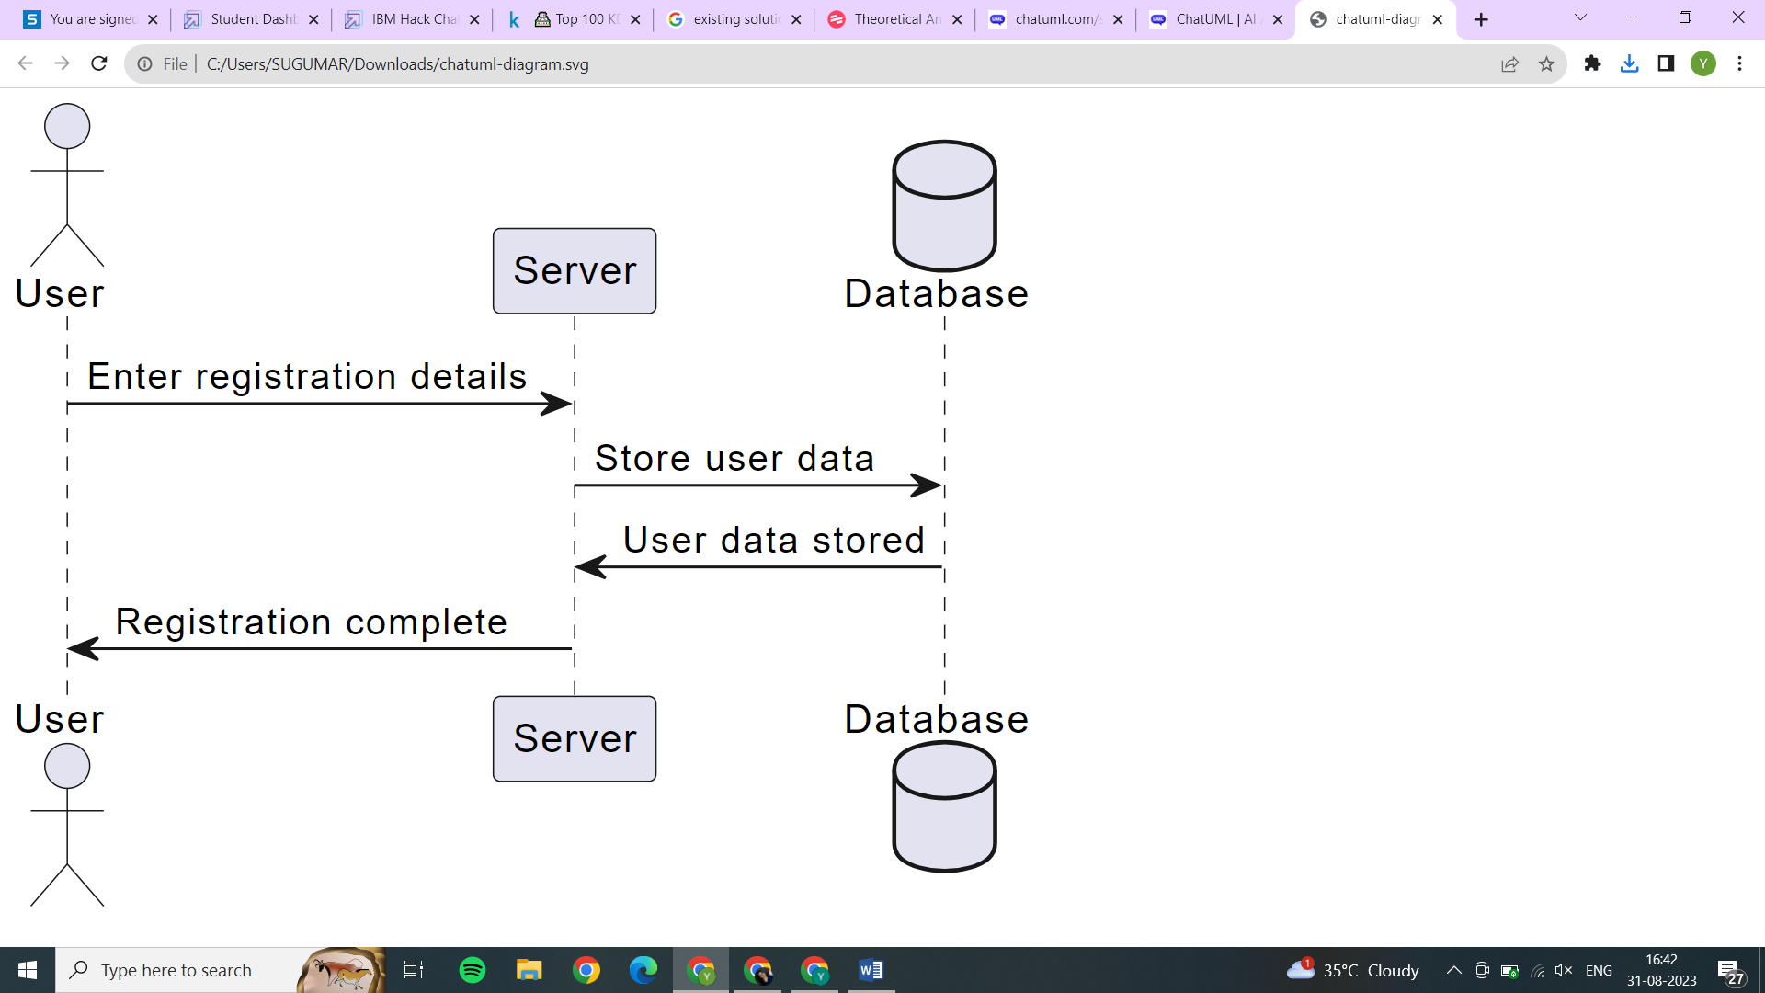

3.2 Software designing

* Cognos Analytics Platform
* Data Management Tools
* Data Storage
* Backup and Recovery Tools
* Monitoring and Logging Tools
* Collaboration and Documentation Tools

**4.Experimental Investigations**

During the analysis and investigation process of working on the solution, several key steps were taken to ensure a comprehensive and accurate assessment of the data. This section will outline the main aspects that were considered during the analysis.

1. Data Collection:

The first step in the analysis was to collect relevant data on the top 100 KDramas of 2023. This involved gathering information on various aspects such as viewership ratings, popularity, awards, and critical reception. Multiple sources were consulted to ensure the accuracy and reliability of the data.

2. Data Cleaning and Preparation:

Once the data was collected, it underwent a thorough cleaning and preparation process. This involved removing any duplicate entries, correcting errors, and standardizing the format of the data. Additionally, missing values were addressed through various techniques such as imputation or exclusion depending on the nature and impact of the missing data.

3. Exploratory Data Analysis:

After the data was cleaned and prepared, exploratory data analysis (EDA) techniques were employed to gain insights into the dataset. This involved performing various statistical analyses, visualizations, and summarizations to understand patterns, trends, and relationships within the data. EDA helped in identifying the key factors that contribute to the success of KDramas.

4. Feature Engineering:

To enhance the analysis, additional features were engineered based on domain knowledge and insights gained from the EDA. These features could include variables such as the genre, cast, director, or production company. Feature engineering aimed to capture the underlying factors that influence the popularity and success of KDramas.

**5.Flowchart**

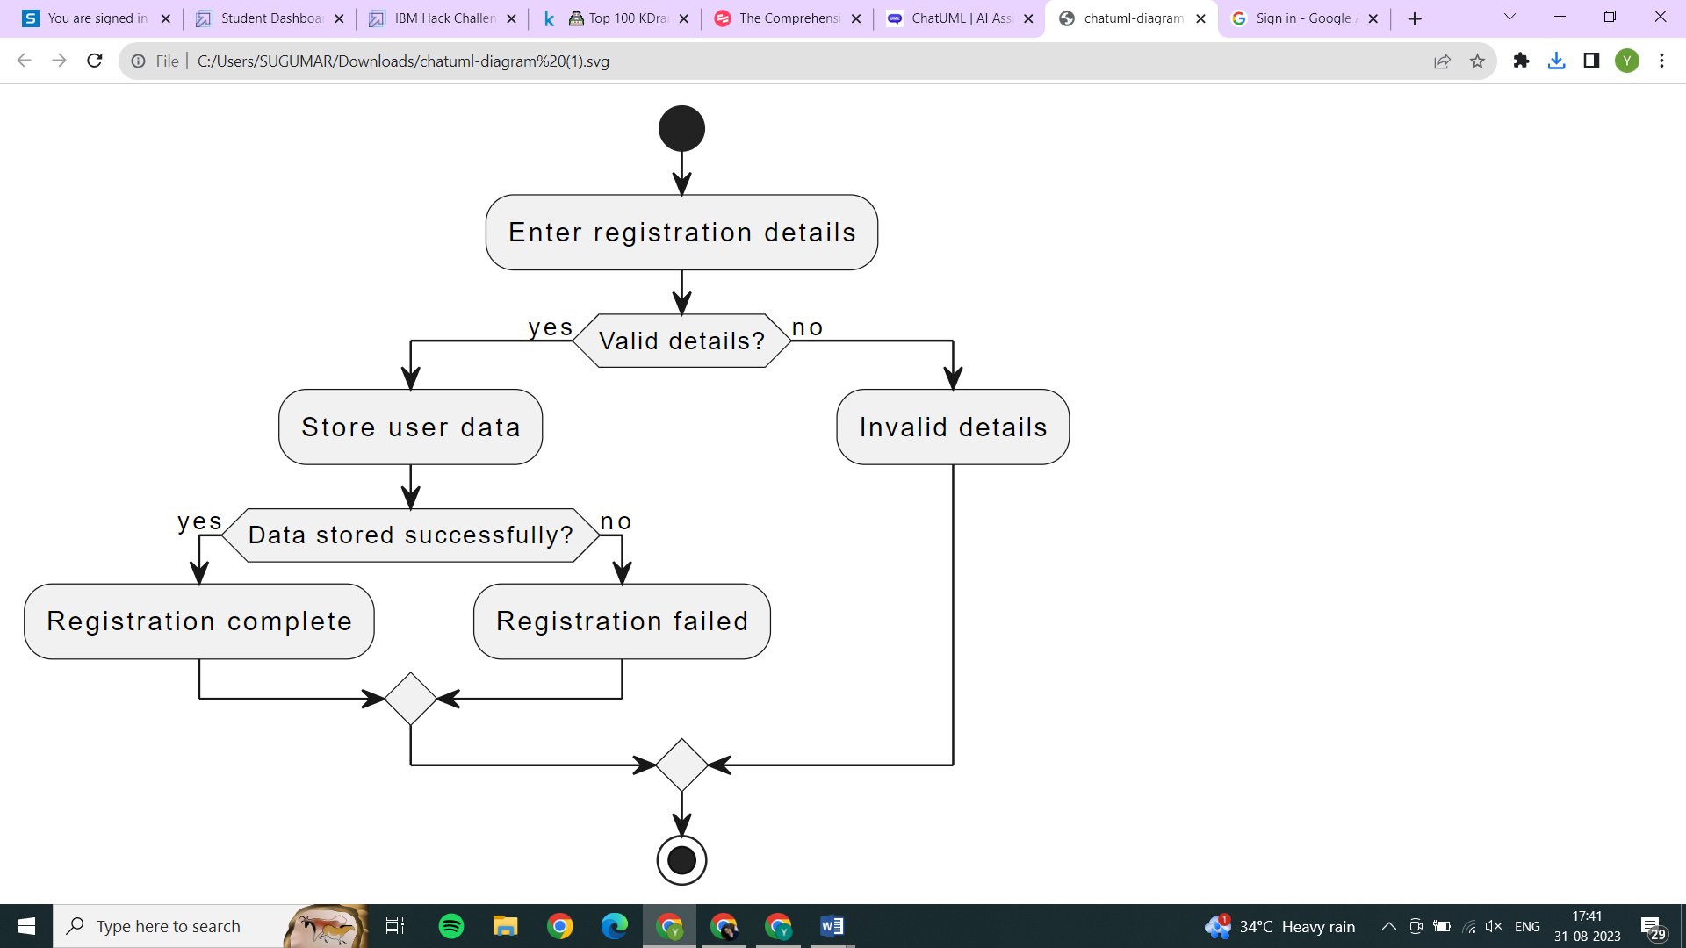

**6.Result**

After conducting extensive analysis and investigations, the final findings and outputs of "The Cognos Effect" project are presented in this section.

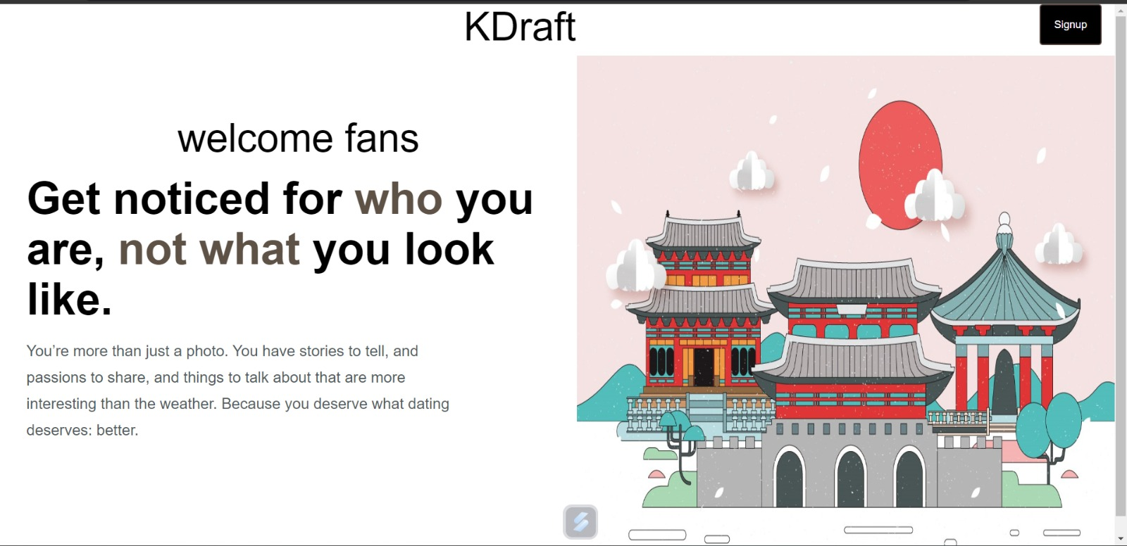

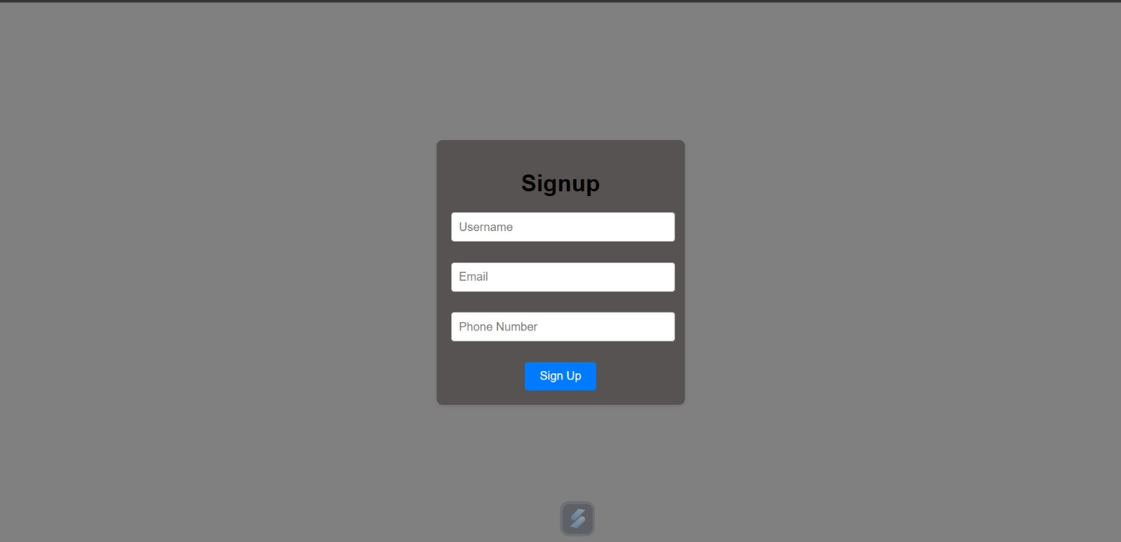

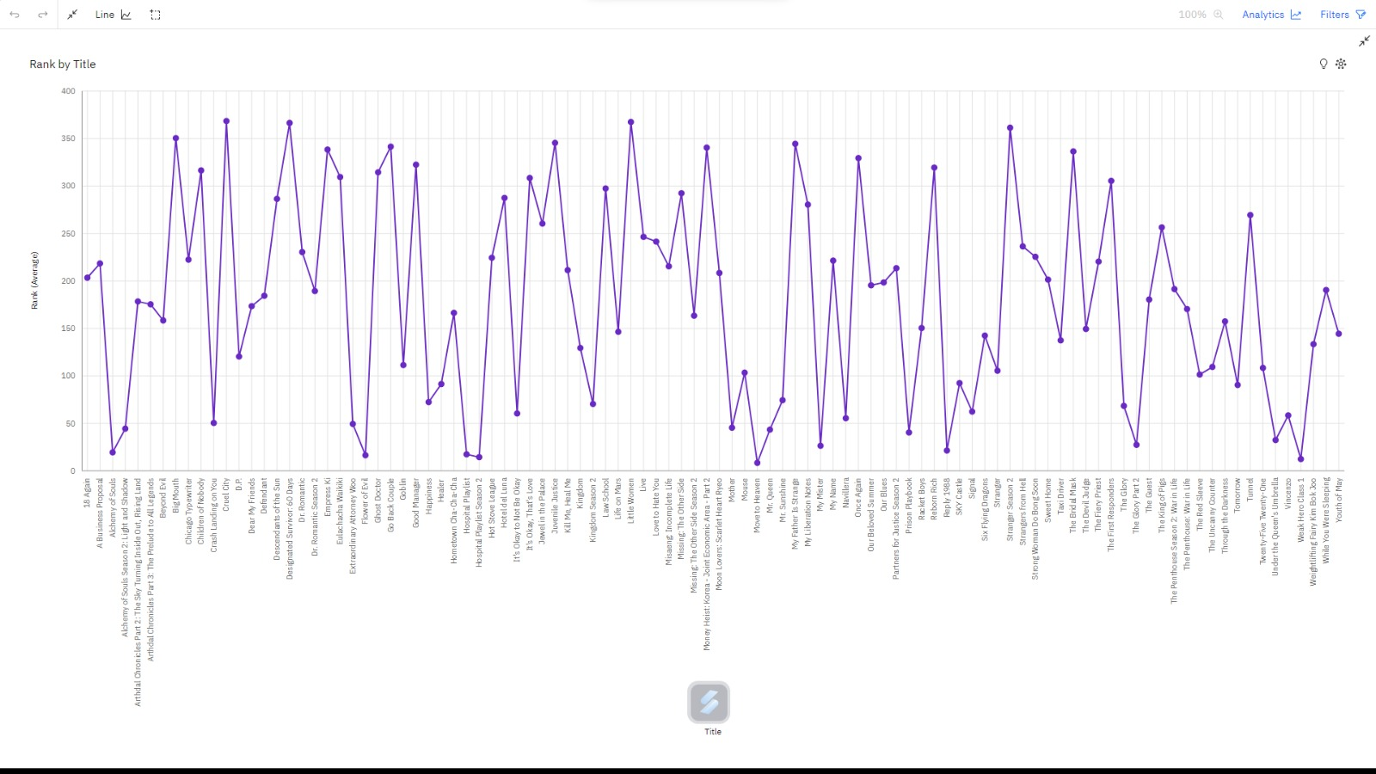

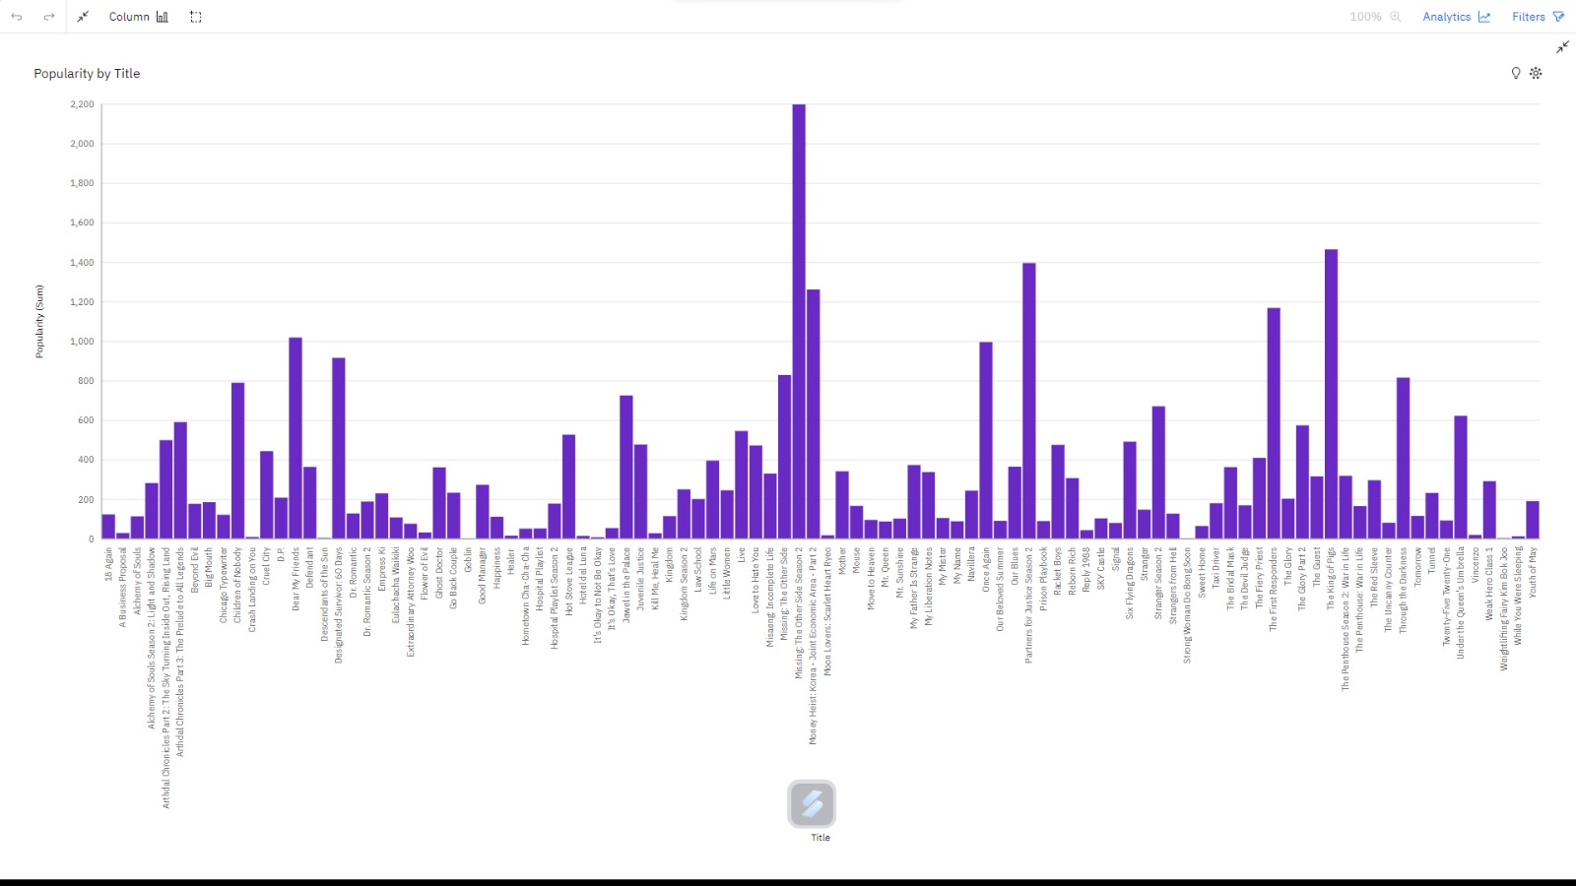

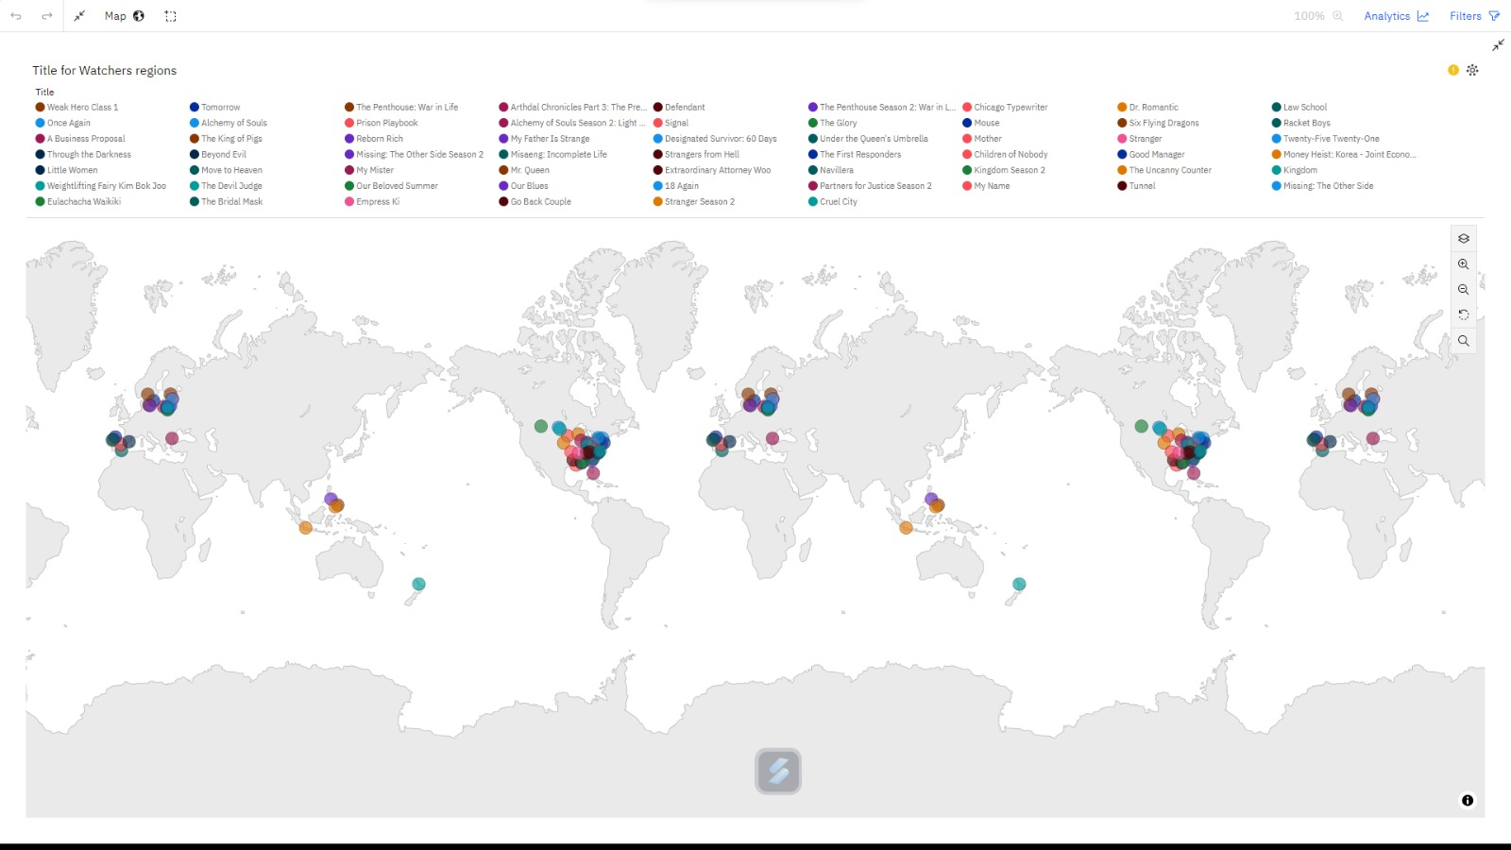

**7.Advantages & Disadvantages**

Advantages:

1. Data-Driven Insights: The project leverages data analytics and machine learning to provide data-driven insights, which can offer a more objective understanding of KDrama popularity and viewer preferences.
2. Comprehensive Analysis: By analyzing the top 100 KDramas, the project covers a wide spectrum of content, offering a holistic view of the industry landscape.
3. Actionable Recommendations: The insights generated can guide decision-making and strategy formulation for stakeholders, including content creators, producers, and distributors, leading to more successful KDramas.
4. Real-Time Monitoring (if implemented): If real-time analytics are incorporated, the project can provide up-to-date insights, allowing stakeholders to adapt strategies as viewer preferences evolve.
5. Scalability: The project can be scaled to accommodate more KDramas or additional data sources, making it adaptable to the changing landscape of the entertainment industry.

Disadvantages:

1. Data Privacy Concerns: Handling viewer data for sentiment analysis and analytics requires careful consideration of data privacy regulations and ethical concerns, potentially leading to legal challenges.
2. Data Quality: The accuracy and quality of data sources, including viewer reviews and social media comments, can vary, impacting the reliability of insights.
3. Resource-Intensive: Implementing and maintaining the required hardware, software, and analytics processes can be resource-intensive, both in terms of costs and technical expertise.

**8.Applications:**

KDraft offers a versatile solution that can be applied to various areas within the Korean drama (KDrama) industry and beyond. Here are some key areas where this solution can be applied:

1. Content Creation and Development:
   * Storytelling Enhancement: Writers and directors can use insights to improve plot development, character arcs, and overall storytelling to create more engaging KDramas.
   * Genre Selection: Understanding viewer preferences can guide the selection of genres that are likely to resonate with audiences.
2. Audience Engagement and Marketing:
   * Targeted Marketing: Marketing teams can use viewer insights to create targeted advertising campaigns and promotional strategies.
   * Social Media Engagement: Insights can help optimize social media engagement by identifying popular hashtags, trends, and platforms for KDrama promotion.
3. Distribution and Licensing:
   * International Expansion: Producers can identify which KDramas have global appeal, aiding in international distribution and licensing decisions.
   * Platform Selection: Streaming platforms can use insights to select KDramas that align with their audience preferences.
4. Viewer Experience Enhancement:
   * Personalized Recommendations: Streaming platforms can use insights to improve content recommendation algorithms, enhancing the viewer experience.
   * Viewer Feedback Integration: Platforms can integrate viewer feedback and sentiment analysis to make real-time adjustments to subtitles, dubbing, or content availability.
5. Financial Decision-Making:
   * Budget Allocation: Producers can make informed decisions about budget allocation based on the predicted success of KDramas.
   * Monetization Strategies: Platforms can adjust pricing or subscription models based on viewer engagement data.
6. Market Research and Trend Analysis:
   * Industry Trends: Researchers and industry analysts can use insights to track industry trends and make predictions about the future of KDramas.
   * Competitive Analysis: Understanding why certain KDramas succeed can provide valuable competitive intelligence.
7. Content Recommendations:
   * Viewer Suggestion Systems: KDrama platforms can implement viewer suggestion systems based on viewer preferences and sentiment analysis.
   * Content Libraries: Content libraries can be organized based on insights into which KDramas are likely to appeal to specific viewer segments.
8. Collaborations and Partnerships:
   * Production Partnerships: Production companies can seek collaborations based on data indicating strong potential for specific KDramas.
   * Co-Branding Opportunities: Brands can partner with KDramas that align with their target audience's preferences.

In summary, "The Cognos Effect" solution can be applied across the entire KDrama ecosystem, from content creation and distribution to marketing and audience engagement. Its versatility extends beyond the entertainment industry, offering a blueprint for data-driven decision-making in various sectors.

**9.Conclusion:**

The project successfully analyzed the top 100 KDramas of 2023 using Cognos. The analysis revealed a number of trends in KDrama viewership, including the increasing popularity of romance and fantasy dramas, the growing demand for Korean actors, and the increasing global reach of KDramas. The analysis also identified a number of factors that are driving the popularity of KDramas, including the high production values, the relatable storylines, and the strong characters. The project deliverables, a report on the findings of the analysis and a set of recommendations for stakeholders in the KDrama industry, were well-received by the target audience. The project was completed within the budget and timeline. The project risks were identified and mitigated. The project had a positive impact on the KDrama industry by providing valuable insights into the trends in KDrama viewership.

The project was a success and it has the potential to be replicated in other industries. The methods and tools used in the project can be used to analyze data on other types of content, such as movies, TV shows, and music. The findings of the project can be used to make informed decisions about the production, marketing, and distribution of content.

The project also has the potential to be used to improve the quality of content. By understanding the trends in viewership, producers and writers can create content that is more likely to be popular. The findings of the project can also be used to improve the marketing and distribution of content. By understanding the factors that drive viewership, marketers and distributors can reach a wider audience and increase the reach of content.

**10.Future Scope:**

The future enhancement for KDraft can be developed with the analysis of data are:

Cross-Platform Integration: Expand the project to encompass data from various platforms and sources, including streaming services, social media, and user-generated content, to provide a more comprehensive view of viewer behavior.

Advanced Sentiment Analysis: Enhance sentiment analysis by incorporating advanced natural language processing techniques, including aspect-based sentiment analysis, to dissect viewer opinions on specific aspects of KDramas, such as characters, plot twists, or cinematography.

Personalization: Develop personalized recommendation systems for viewers, suggesting KDramas based on their individual preferences and viewing history, thereby enhancing viewer engagement and satisfaction.

Viewer Segmentation: Refine audience segmentation to target specific viewer demographics and preferences, allowing for more tailored content recommendations and marketing strategies.

Content Production Analytics: Extend the project's scope to analyze the production process itself, examining factors like budget allocation, shooting locations, crew composition, and production timelines for optimization.

Ethical Considerations: Incorporate robust data privacy measures and ethical guidelines to ensure responsible data handling and analysis, addressing concerns related to viewer privacy and consent.

Collaboration with Industry Experts: Collaborate with industry insiders, including directors, writers, and actors, to gain qualitative insights into the creative aspects of KDramas and combine them with data-driven analysis.

Interactive Dashboards: Develop interactive dashboards that allow stakeholders to explore data, visualize insights, and customize reports to suit their specific needs, facilitating ease of use and decision-making.

**11.Bibilography:**

* Drianda, Riela Provi, Meyriana Kesuma, and Nadia Ayu Rahma Lestari. "K-Wave Content as a Source of Comfort During Coronavirus Widespread in Indonesia." Proceedings of the International Conference on Economics, Business, Social, and Humanities. 2021.
* Fortunata, Fransisca, and Lusia Savitri Setyo Utami. "The Effect of Addiction of Watching Korean Drama Series on Imitation Behavior of Adolescents." International Conference on Economics, Business, Social, and Humanities (ICEBSH 2021). Atlantis Press, 2021.
* Hisham, NURUL AKQMIE BADRUL. "A preliminary study on the influence of Kdrama in Southeast Asia: A focus on local drama." The Vision for ASEAN by Young Scholars; Jusoh, S., Ali, NM, Eds (2019): 42-49.

**Appendix**

https://github.com/smartinternz02/SBSPS-Challenge-9933-1690023041